FSGA Summer Conference 2025 — Marketing Instructions
Create Your Personalized “I’m Attending” Graphic in Canva
We’ve made it easy for you to promote your attendance at the FSGA Summer Conference! Follow these quick and simple steps to customize your own “I’m Attending” graphic using Canva. You’ll add your name, title, company, and photo—and feel free to include anything else you’d like to share.
Why?
To help spread the word to your network that you're attending the FSGA Conference—and encourage them to join you!

Step-by-Step Instructions
1. Open the Canva link
Click the link provided to access the graphic template: Click to open graphic
2. Duplicate the template
At the top right of the Canva editor, click the “Duplicate Page” button. This ensures you're working on your own version and not editing the shared template.
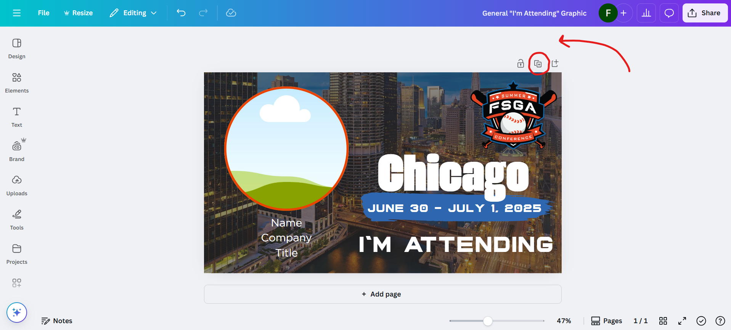
3. Add your information
Click into the text boxes and update them with your name, title, company, and any other info you'd like to share.
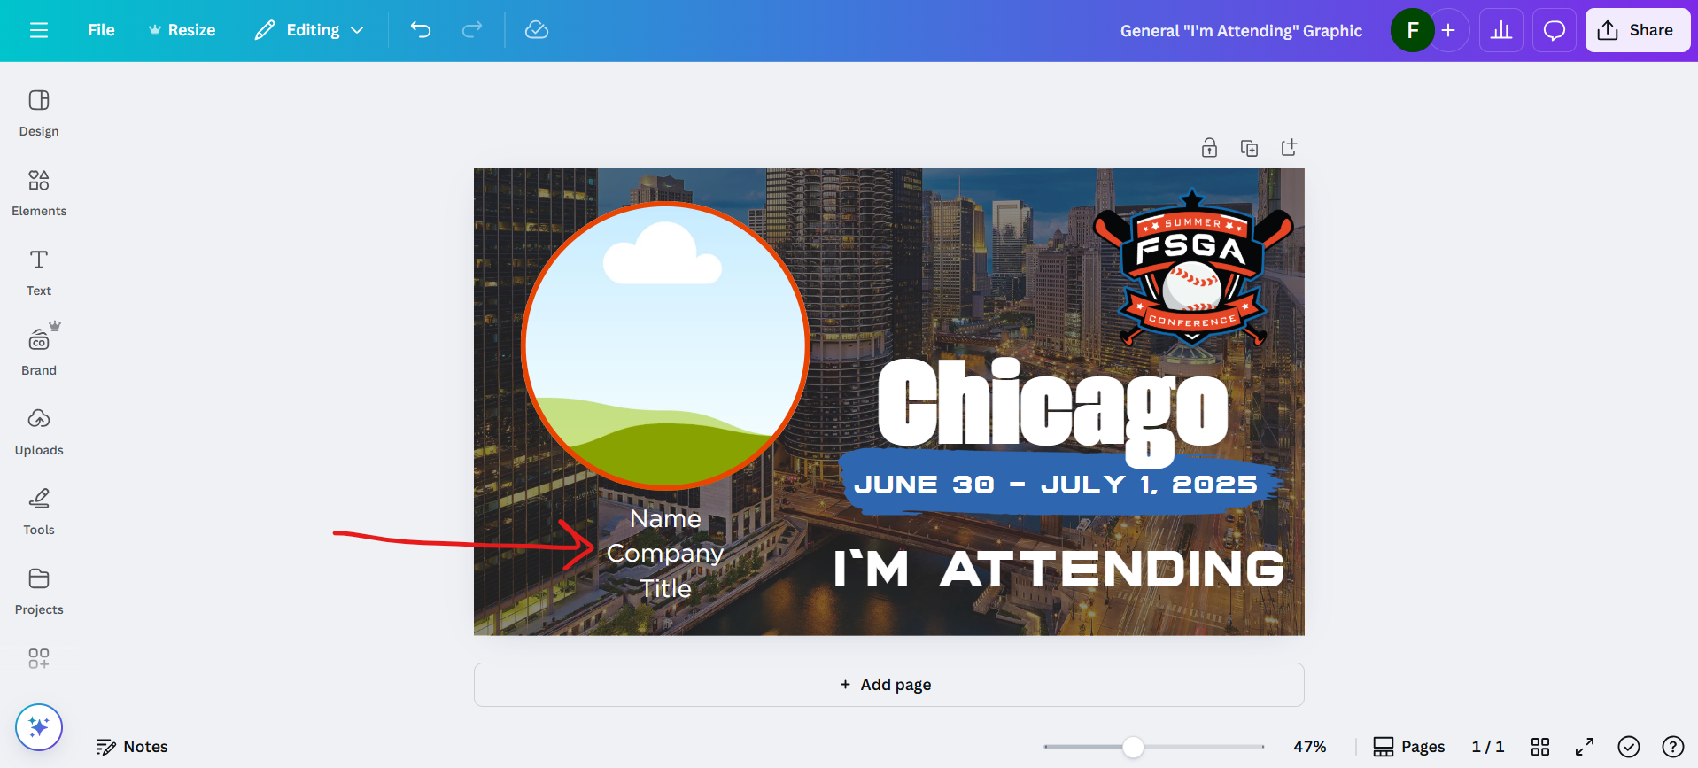
4. Upload your photo
- On the left toolbar, click “Uploads”, then select “Upload files” to choose your photo.
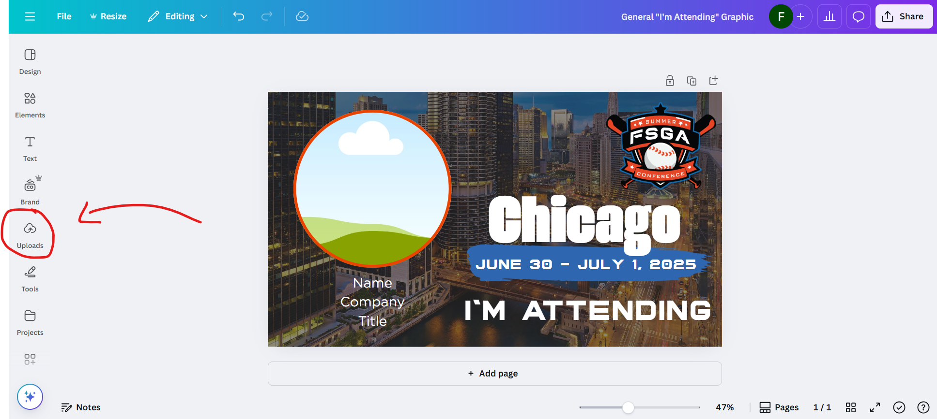
- You may need to log in to Canva first—Google login is quick and easy if you have a Google account.
- Once uploaded, drag your photo into the circle image placeholder.
- To adjust your photo inside the frame, simply double-click it and reposition as needed.
5. Download your completed graphic
- When you're done editing, click “Share” in the top-right corner.
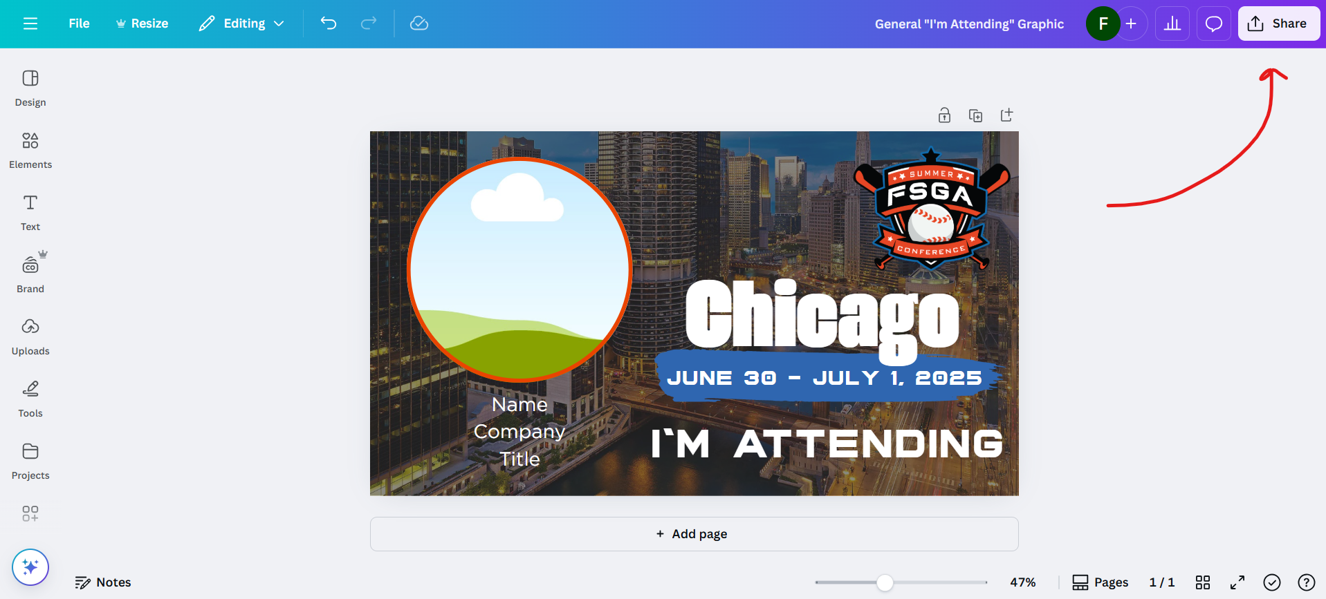
- Then click “Download” and choose your preferred file type (PNG is recommended).
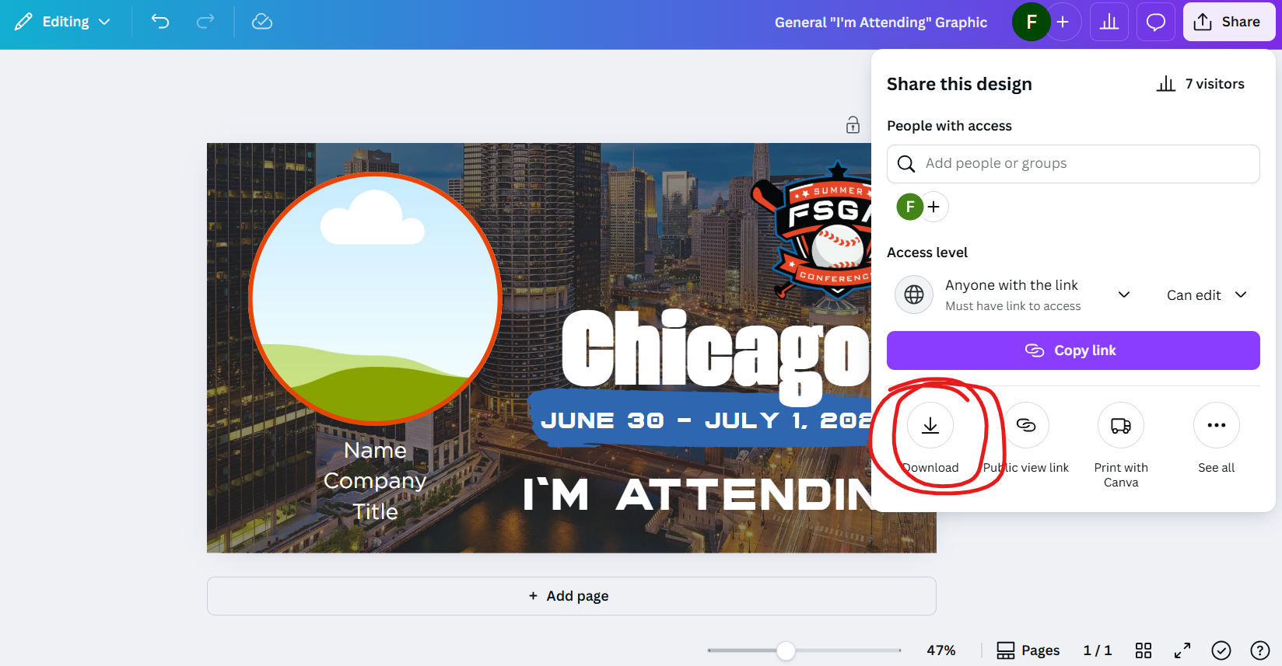
- Click “Download” again, and you’re all set!
6. Clean up your page
To keep the template clean for others, delete your duplicated page after you've downloaded your graphic. Just hover over your customized page, click the trash can icon, and confirm deletion.
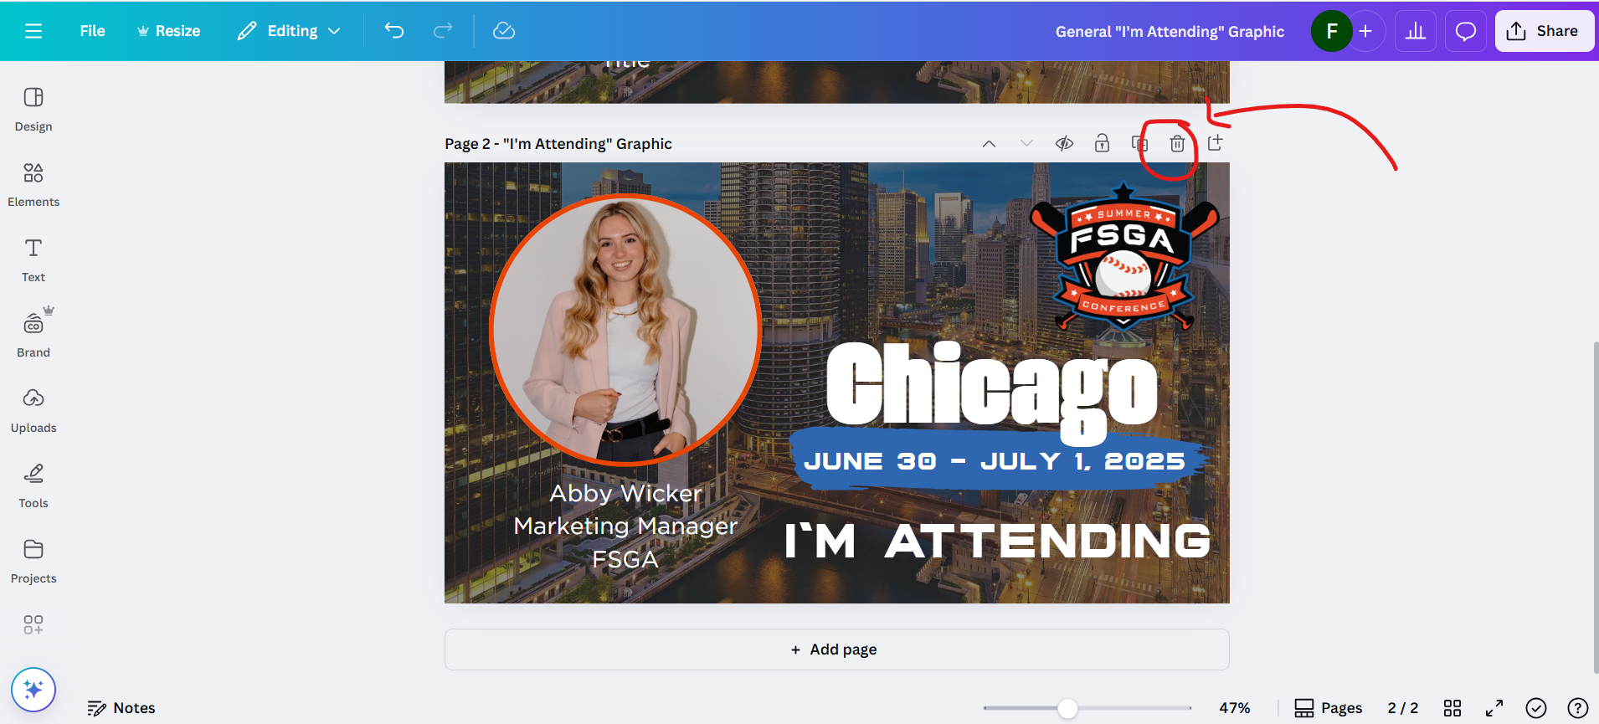

Need Help?
If you run into any issues, don’t hesitate to reach out to awicker@thefsga.org—she’s happy to assist.
Bonus: Check the main page for suggested captions you can use when posting your graphic.
Thanks for helping us spread the word—we can’t wait to see you at the FSGA Summer Conference 2025!

